Year 11 Document Analysis – Skills (Weimar)

Questions: Try at least four of these….
- What is the message and purpose of Source 1? (clue: look carefully at the cartoon’s elements!)(4m)
- Identify the sections of German society illustrated in Source 2. 2m)
- What is the cartoonist saying about the Weimar Republic? (2m)
- What is the perspective of the cartoonist in Source 3? (2m)
- How useful is this source when assessing the Treaty of Versailles? (Useful – comment on the origin of the source, any bias?, motive and purpose?) (3m)
- Compare and contrast the messages of Source 2 and Source 4. (4m)
- What is the context of Source 5? (5m)
- With reference to the sources, identify the relationships between key events, people and ideas that explain the nature of post-war German society. (7m)
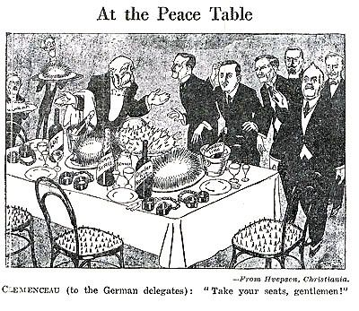
SOURCE 1: Cartoon on the Treaty of Versailles, 1919.

Clemenceau (to the German delegates): “Take your seats, gentlemen!”

SOURCE 2: REPUBLIK cartoon produced in the late 1920s in Germany.

SOURCE 3: The Allied Touch, 1919. Cartoon produced in Germany in 1919; ‘Germany slapped by Versailles hand’

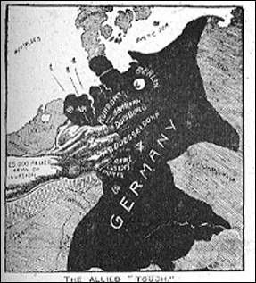

SOURCE 4: Extracts from a speech made by Adolf Hitler, January 31, 1933.
“………It is an appalling inheritance which we are taking over. The task before us is the most difficult which has faced a German statesman in living memory. But we must all have unbounded confidence for we believe in our nation and in its eternal values.. Farmers, workers and the middle class must unite to contribute the bricks wherewith to build the new Reich.
The National Government will therefore regard it as its first and supreme task to restore to the German people unity of mind and will……. It will rise above position and class to bring our people again to the awareness of racial and political unity and the duties arising from this….. It will make national discipline govern our life….Within four years the German farmer must be free from impoverishment. Within four years unemployment must be permanently overcome……

SOURCE 5: Three images from Germany in 1923.

(i) French soldiers and a German worker in the Ruhr.
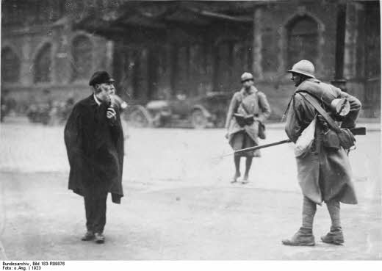

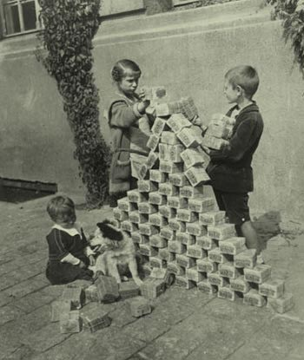
(ii) Photo of children playing with money in 1923. (iii) Photo of Nazis behind their barricade during the Munich Putsch.

